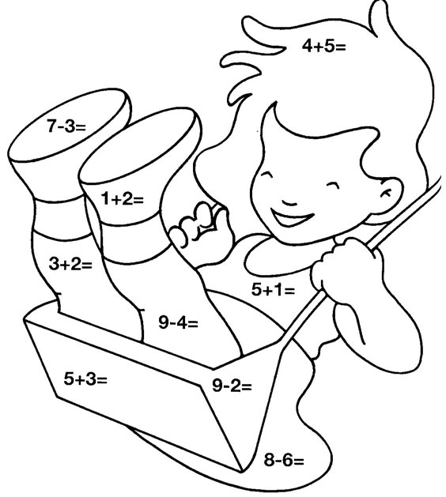

|  |  |  |  |  |  |  |  |
| --- | --- | --- | --- | --- | --- | --- | --- |
| **9** | **4** | **3** | **5** | **6** | **8** | **7** | **2** |
|  |  |  |  |  |  |  |  |

**Matemática – 3ºAno _ Nível II**

**Nome:_____________________________________ Data: / /**

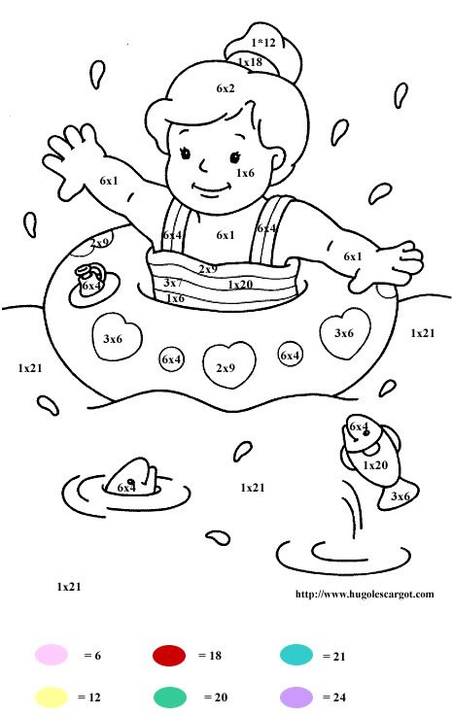

**Matemática – 3ºAno _ Nível II**

**Nome:_____________________________________ Data: / /**